Synopsis

Project Title- Clinical Risk Assessment for type-2 Diabetes

Problem Id: 7

Student Name- Smriti Singh
University Roll number- 2028859
Section-G

Student Name- Sanya Verma
University Roll number- 2028839
Section-G

- Problem Description:
Type-2 Diabetes is one of the most common chronic diseases affecting millions of people worldwide. Detecting the risk of diabetes at an early stage is very important because it helps prevent serious health complications such as heart disease, kidney problems, nerve damage, and vision loss. In many cases, diabetes is diagnosed only after noticeable symptoms appear, which can make treatment more difficult. Therefore, using modern technologies like Machine Learning can help in identifying individuals who are at risk much earlier.
In this project, a machine learning model will be developed to assess the risk of Type-2 Diabetes using important health parameters such as Age, Body Mass Index (BMI), and Insulin levels. A synthetic dataset containing around 250 patient health records will be generated based on realistic medical ranges. Before training the model, the dataset will be preprocessed using techniques such as Label Encoding and StandardScaler to convert categorical values into numerical form and normalize the data.
Finally, a Logistic Regression model will be used to predict whether a person is likely to develop diabetes. The model’s performance will be evaluated using a Confusion Matrix and Recall metric to ensure that individuals who are at higher risk are correctly identified.

- Steps of Implementation:
1. Data Collection / Data Generation
In the first step, a synthetic dataset of around 250 patient health records will be created. The dataset will include important health parameters such as Age, Body Mass Index (BMI), and Insulin levels, which are useful for predicting the risk of Type 2 Diabetes.
2. Data Preprocessing
After generating the dataset, the data will be cleaned and prepared for analysis. If there are any categorical values, Label Encoding will be applied to convert them into numerical form so that the machine learning model can process them.
3. Feature Scaling
To ensure that all the input features are on a similar scale, the StandardScaler technique will be used. This helps improve the performance and accuracy of the machine learning model.
4. Model Selection
In this project, Logistic Regression will be selected as the classification algorithm to predict whether a person is likely to develop diabetes or not.
5. Training and Validation
The dataset will be divided into two parts: a training set and a testing set. The training data will be used to train the model, while the testing data will help evaluate how well the model performs on new data.
6. Model Evaluation
The performance of the model will be checked using evaluation metrics such as Confusion Matrix, Accuracy, Precision, and Recall to understand how accurately the model predicts diabetes risk.
7. Final Model
Once the model performs satisfactorily, the final trained model can be used to predict the risk of diabetes for new patient data.

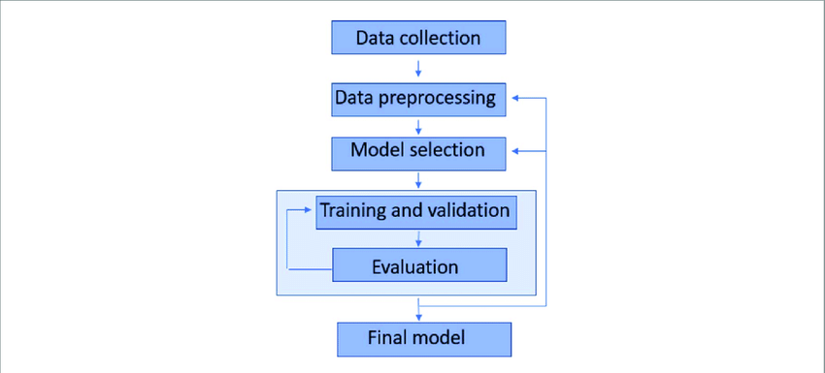
Fig. 1 Sample architecture
- Expected Modules/ Libraries to be used :

In this project, different Python libraries will be used to perform data processing, model training, and visualization tasks related to predicting the risk of Type 2 Diabetes.

- Pandas
Pandas will be used for handling and organizing the dataset. It helps in reading, storing, and manipulating data in a structured format such as tables.

- NumPy
NumPy will be used for performing numerical operations and generating synthetic data required for the dataset.

- Scikit-learn
Scikit-learn provides useful machine learning tools that will be used in this project. It will help in implementing algorithms such as Logistic Regression, applying StandardScaler, splitting the dataset, and evaluating the model performance.

- Matplotlib
Matplotlib will be used to create graphs and plots to visualize the dataset and model results.
- Seaborn
Seaborn will be used for advanced visualizations such as heatmaps and confusion matrix plots, which make the data easier to understand.

- Expected Evaluation metrics and Plots to be used:
To understand how well the machine learning model performs, several evaluation metrics will be used. These metrics help in checking how accurately the model predicts the risk of Type 2 Diabetes.
Confusion Matrix
A Confusion Matrix will be used to show the number of correct and incorrect predictions made by the model. It helps in understanding how many cases were correctly classified and how many were misclassified.
Accuracy
Accuracy measures the overall performance of the model by showing the percentage of correct predictions out of all predictions made.
Recall
Recall is an important metric for this project because it shows how many actual diabetes cases are correctly identified by the model. This is useful in medical prediction where missing a positive case can be risky.
Precision
Precision measures how many of the predicted positive cases are actually correct. It helps in checking the reliability of the model’s positive predictions.
Visualization Plots
To better understand the dataset and the model performance, different visualization plots will also be used:
- Confusion Matrix Heatmap – Displays the confusion matrix in a visual format to easily understand prediction results.
- Feature Distribution Plots – Show how different health parameters like age, BMI, and insulin levels are distributed in the dataset.
- Correlation Heatmap – Helps in identifying relationships between different features in the dataset.
These visualizations make it easier to analyze the data and understand how different factors contribute to predicting diabetes risk.

- Required topics from the subject:

- Data Structures (Arrays / Lists)
Data structures such as arrays or lists will be used to store and manage the health record values in the dataset. They help in organizing the data so that it can be easily processed and used during model training.

- File Handling
File handling will be used to read and store the dataset in file formats such as CSV or Excel. This allows the data to be saved, accessed, and reused whenever needed during the project.

- Functions
Functions will be used to divide the program into smaller and manageable parts. Different functions can be created for tasks like data preprocessing, model training, and model evaluation, which makes the code more organized and easier to understand.

- Platform Required:
The project will be developed using the Python programming language. The implementation and testing of the model will be carried out in Jupyter Notebook within the Anaconda environment. These tools provide a simple and interactive platform for writing code, performing data analysis, training machine learning models, and visualizing the results effectively.
- Books and Link Sources:

- Dataset
Diabetes_type2raw.xlsx

• Scikit-learn Official Documentation
https://scikit-learn.org
This website provides detailed information and examples for implementing machine learning models.
• Pandas Official Documentation
https://pandas.pydata.org
This resource is helpful for understanding how to work with datasets and perform data manipulation in Python.

